Project Design Phase-II
Data Flow Diagram & User Stories

Date | 08 Mar 2026
Team ID | SWTID-2026-1170
Project Name | MicroGoal
Maximum Marks

Data Flow Diagrams:
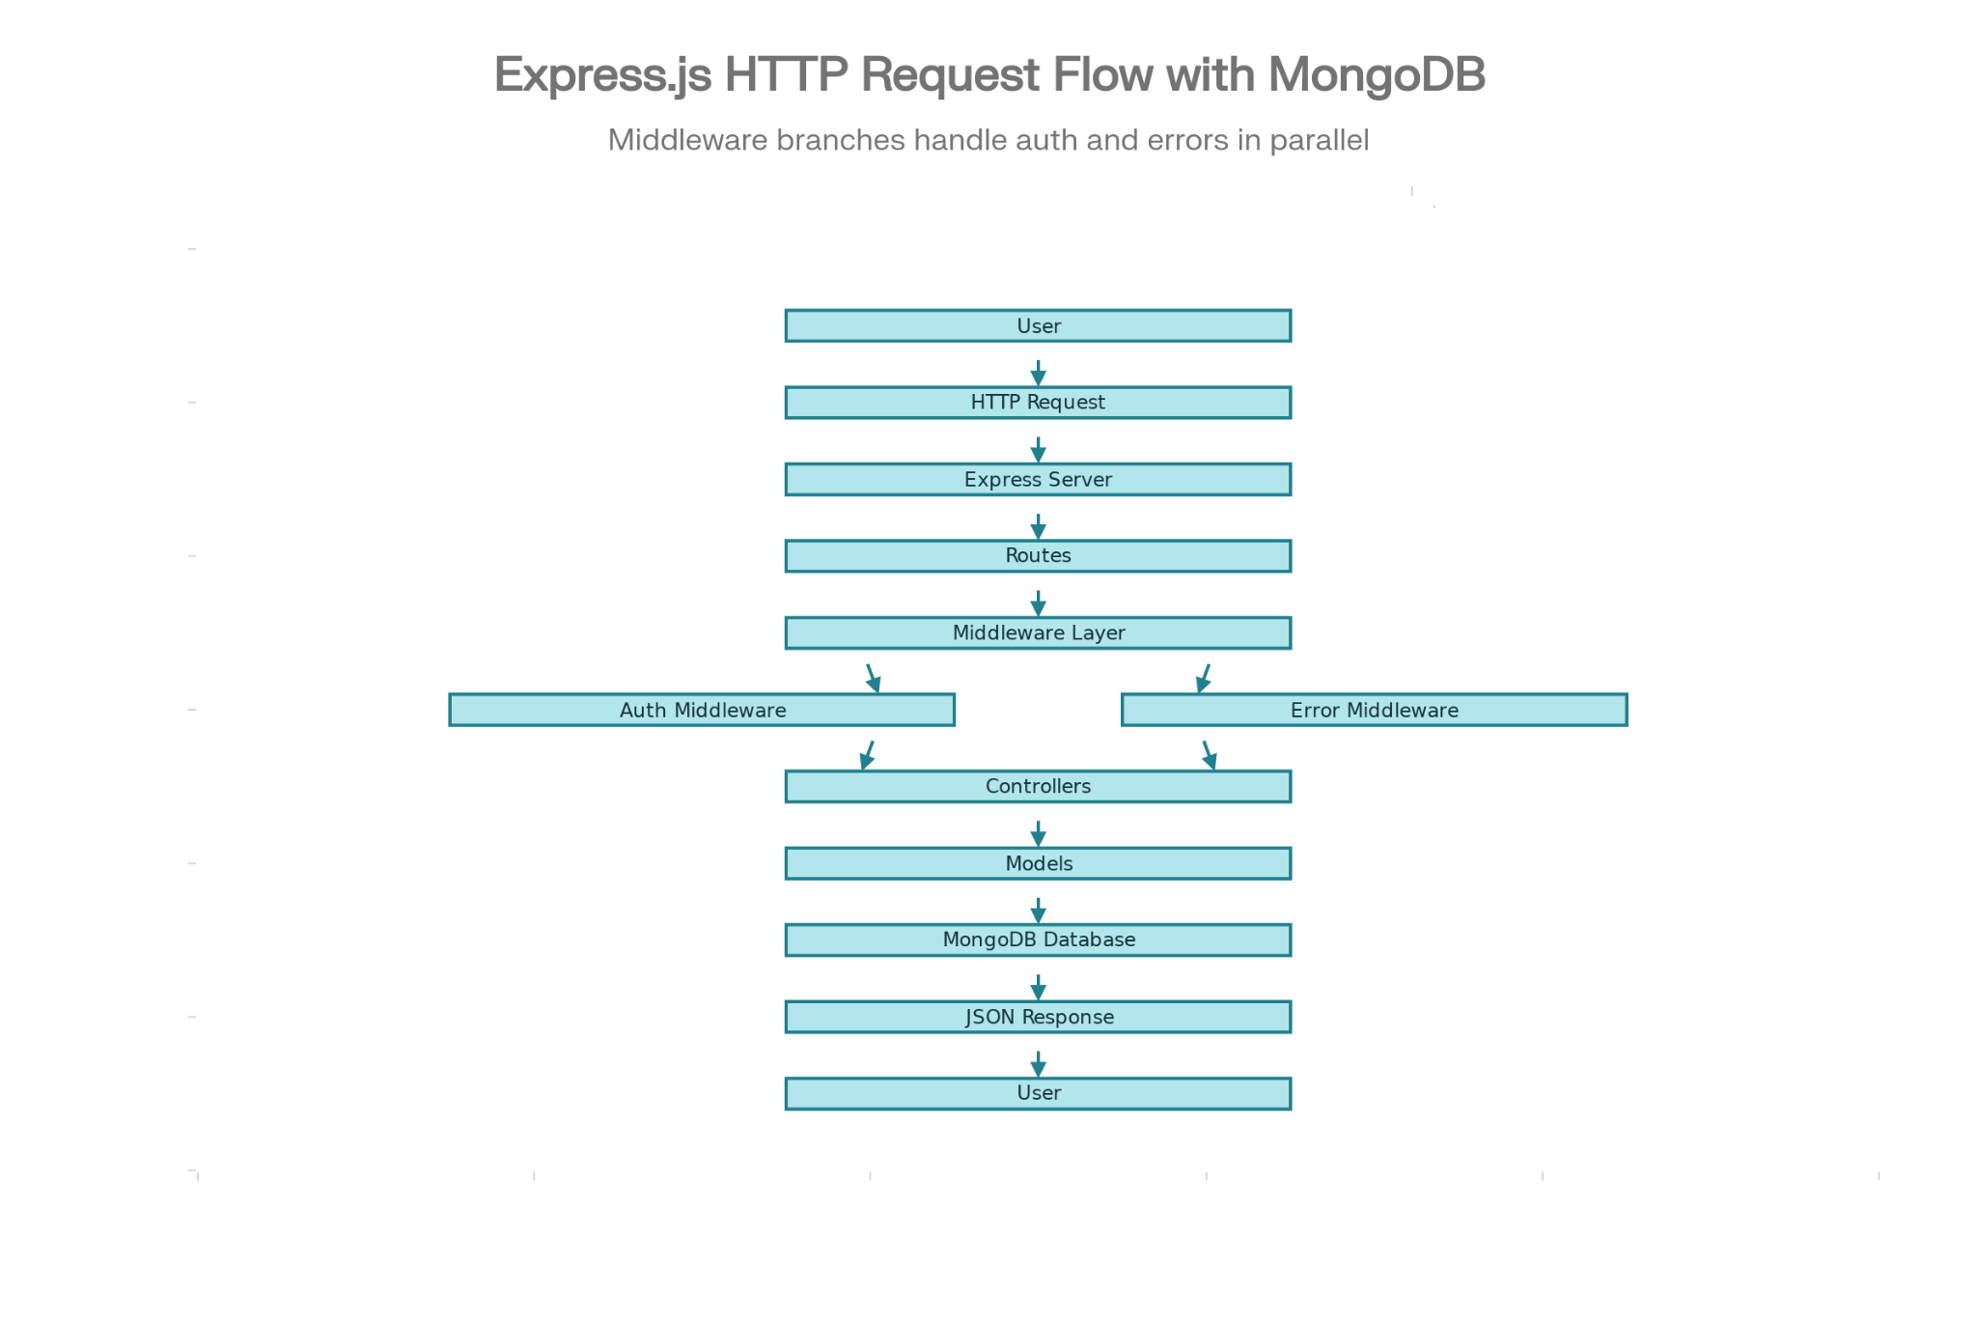
User Stories – MicroGoals Backend API:-
User Type | User Story Number | User Story / Task | Acceptance Criteria | Priority | Release
Customer (Web User) | USN-1 | As a new user, I want to sign up for an account so that I can use the application features. | User registration details are stored in the database and the system returns a success response. | High | Sprint-1
Customer (Web User) | USN-2 | As a registered user, I want to log in securely to access my personal dashboard and goals. | When a valid email and password are provided, a JWT token is generated and a 200 status code is returned. | High | Sprint-1
Customer (Web User) | USN-3 | As a user, I want to add a new goal so that I can organize and track my tasks. | The new goal is stored in the database and the system returns a 201 status code. | High | Sprint-1
Customer (Web User) | USN-4 | As a user, I want to see the list of my goals so that I can monitor my progress. | Only authenticated users can retrieve and view their own goals. | High | Sprint-1
Customer (Web User) | USN-5 | As a user, I want to edit my existing goals so that I can update or modify task details. | Changes made to the goal are successfully updated in the database. | High | Sprint-1
Customer (Web User) | USN-6 | As a user, I want to remove goals that are completed or no longer needed. | The selected goal is permanently removed from the database and a success message is returned. | High | Sprint-1
Customer (Web User) | USN-7 | As a user, I want my account data to remain secure so that other users cannot view or modify my goals. | If an unauthorized request is made, the system returns a 401 Unauthorized error. | High | Sprint-1
Developer / Admin | USN-8 | As a developer, I want to verify API endpoints to ensure they function correctly. | All API endpoints return the expected responses and status codes when tested using Thunder Client. | Medium | Sprint-2
Developer | USN-9 | As a developer, I want a centralized error handling mechanism so that system errors are managed consistently. | Errors are processed through middleware and meaningful error messages are returned to the client. | Medium | Sprint-2

